Вступление - Об OS/2
OS/2 это операционная система, первоначально созданная совместно Microsoft и IBM (но позднее разрабатываемая только IBM), с начала 80-х и до конца 90-х. osFree это попытка воссоздать функциональность этой ОС и ее подсистем в среде, близкой к ее финальной версии (Warp 4). К сожалению, разработка OS/2 была практически свернута в 1996 с выпуском OS/2 Warp 4, и продукт был в конце концов удален из линейки продуктов IBM в декабре 2006. Тем не менее, компания под названием Serenity Systems по соглашению с IBM, получила право выпускать OS/2 под брендом eComStation, модернизировала ее, и она продолжает продаваться по сей день. OS/2 характеризуется ее способностью запускать не только свои собственные приложения, но также и 16-битные windows и DOS приложения.

Как все начиналось
IBM and Microsoft created the original OS/2 1 product under Microsoft's label. It did not initially come with a GUI, however this was changed later. OS/2 2.1 was then released, however, when Microsoft realized that their product Windows was generating more of a profit to them than OS/2 was, development of OS/2 shortly ceased and IBM's relationship with Microsoft crumbled. The OS/2 2.1 kernel which Microsoft developed would eventually be modified and changed to become the Windows NT kernel, the kernel which serves its purpose in today's modern windows versions after the Win9x lineage was cut from the product line with the release of Windows ME.

The Warp Years
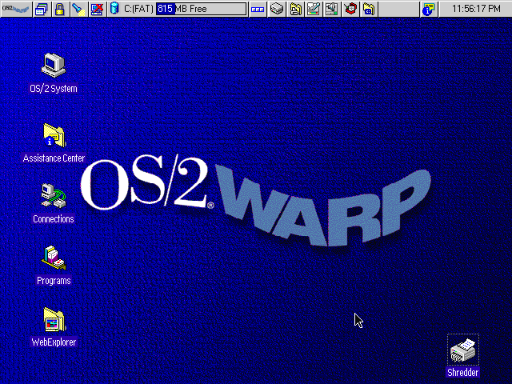OS/2 Screenshot
IBM was not deterred by its problems with Microsoft and persevered with OS/2 development. They released a 32-bit version of OS/2 under the alias of OS/2 Warp 3. It intoduced the Workplace Shell - the user environment that is used in further versions of OS/2 and eComStation.
IBM then released OS/2 Warp 4 - the final version of OS/2 to be released. It included many improvements to OS/2 Warp 3, and featured several features that its Microsoft counterpart did not have, at least in the standard installation.

The Death
After the release of OS/2 Warp 4, OS/2 slowly withered away as a serious competitor in the market. IBM did not make any further releases and public interest waned. By December 2006, IBM officially dropped <acronym titleOS/2 from its product line, offering support to those who were willing to pay for their continued support. IBM now favors Unix like environments, and offers a OS/2 migration article for this purpose.

Rebirth and Continued Support
Even after IBM has withdrawn OS/2, its community and companies continue its legacy.

eComStation
Serenity Systems published eComStation, which is based on OS/2 Warp 4 with several enhancements, including a heavily modified version of the open source OS/2 enhancement kit - the xWorkPlace shell integrated into eComStation.

osFree
osFree is a project aimed at creating an open source OS/2 clone that is compatible and at the level of OS/2 Warp 4. The project stalled in 2005, but now osFree has been taken with new interest, and the project lives on actively developed.

Voyager
The Voyager project is a project similar to osFree's attempts at creating an OS/2 clone, but however it looks at creating a clone in a different way than osFree.

