Task Manager
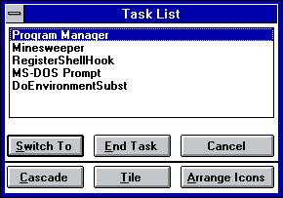Task Manager

Download
You can download source code and binaries from GitHub. Task Manager comes under osFree license.
Win16 Applications
Calculator Calendar CARDFILE CHARMAP Clipboard Viewer Clock Control Panel DRWATSON EXPAND FASTOPEN MPLAYER MSD Notepad PACKAGER PBRUSH PIF Editor printman Program Manager regedit setup SOL soundrec System Configuration Editor Task Manager WINFILE WINHELP Minesweeper winsheld Windows Version write
Win16 Applications
Calculator Calendar CARDFILE CHARMAP Clipboard Viewer Clock Control Panel DRWATSON EXPAND FASTOPEN MPLAYER MSD Notepad PACKAGER PBRUSH PIF Editor printman Program Manager regedit setup SOL soundrec System Configuration Editor Task Manager WINFILE WINHELP Minesweeper winsheld Windows Version write

