Click on a thumbnail to enlarge. Oldest screenshots are shown first.

osFree screenshots

Version 0.0.2
All screenshots in this section are of software currently under development.
Boot Sequence | With Original Bootsector
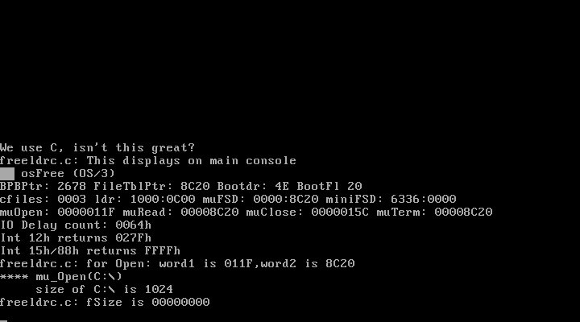osFree 0.0.2 Boot Sequence(In Development) | 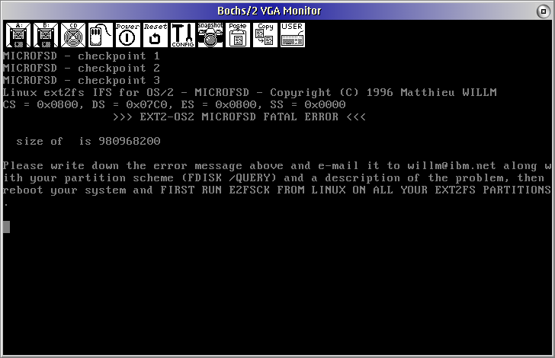 osFree 0.0.2 Boot Sequence(In Development)
Boot Sequence with LILO 1) | OS/2 Test Application 2)
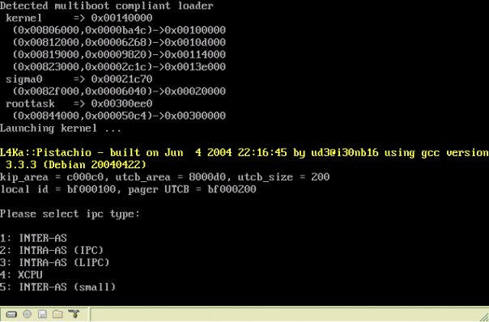osFree 0.0.2 Boot Sequence(In Development) | osFree 0.0.2 OS/2 test application (In Development)
OS/2 Application Output 3)
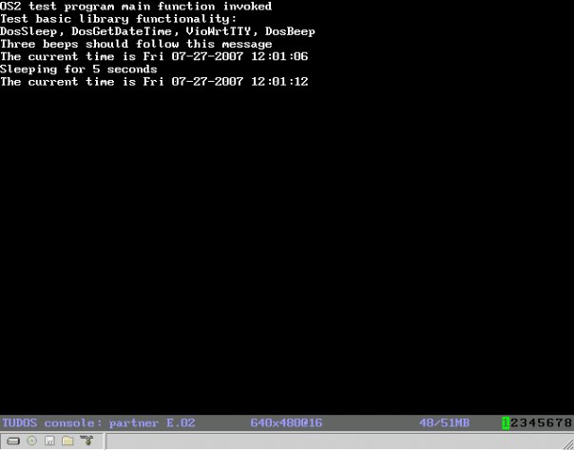Output of test application to L4Con server.

Version 0.0.3
OS/2 Personality server 4)
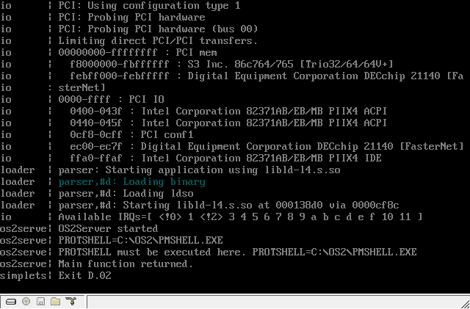CONFIG.SYS parsed...
FreeLdr boot menu 5) | FreeLdr boot menu 6)
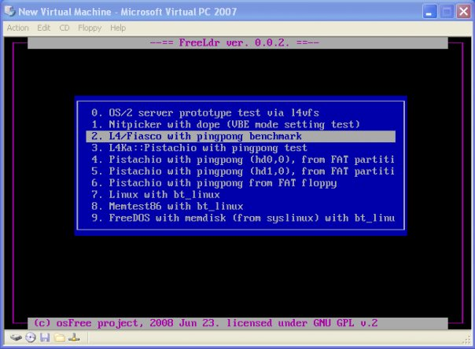FreeLdr boot menu | 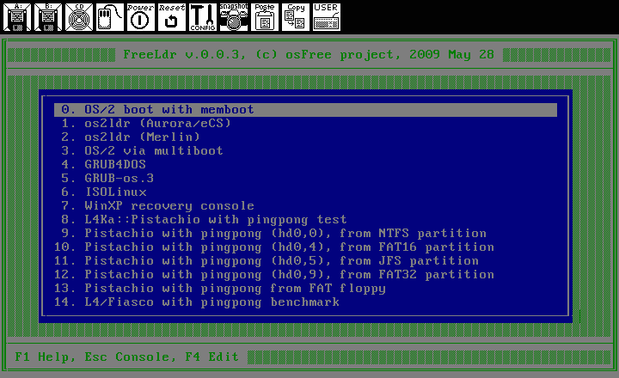FreeLdr boot menu

Version 0.0.4
OS/2 LX Executable (Win32 host) 7) | OS/2 LX Executable (L4 host) 8)
LX executable works... | 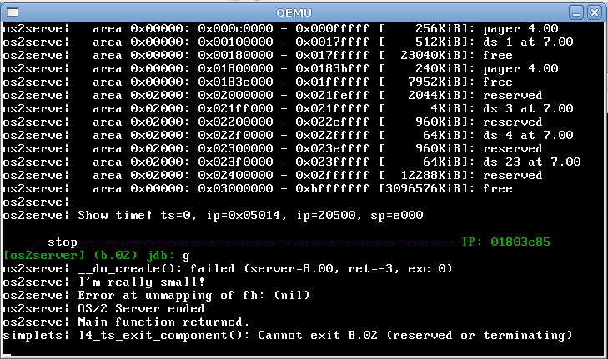LX executable works...
FreeDOS startup | argenv.exe (arguments and environment test)
FreeDOS startup | 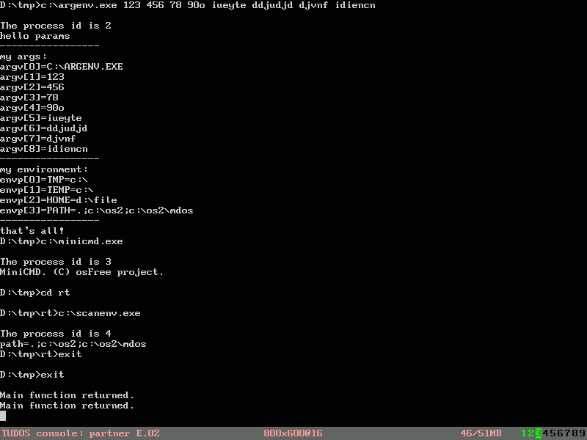argenv test
sort.exe (DosOpen test)
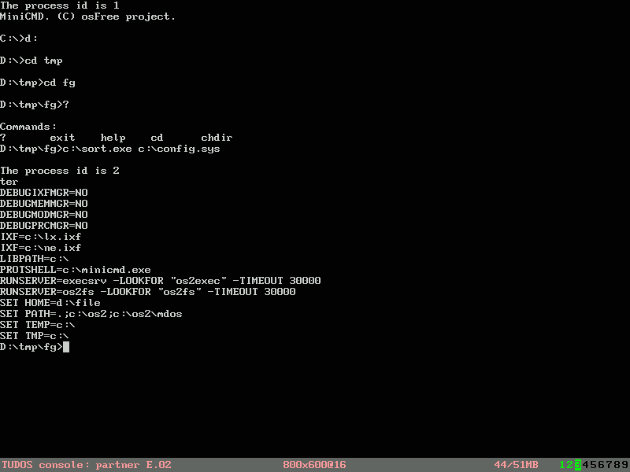sort.exe

Version 0.0.5
FreeLDR 0.0.5 main screen 9)
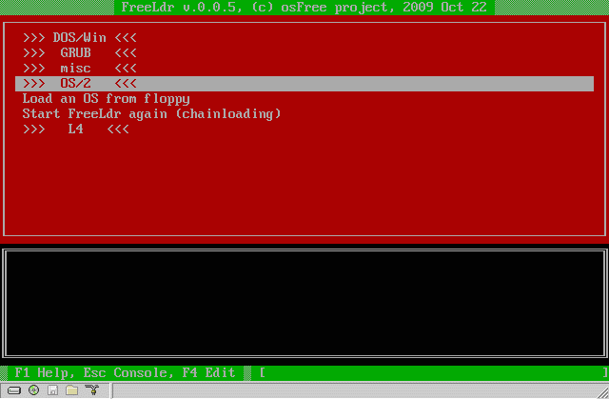FreeLDR 0.0.5

1)Here you can see result of FreeLDR, Kickstart, L4Ka:Pistachio, sigma0 server and initial screen of pingpong application.
2)Here you can see result of GRUB, Bootstrap, Fiasco and core servers with ongoing port/reimplementation of OS2Linux for L4 microkernel. Output to log server.
3)Same as above, but output to graphical L4Con console.
4)CONFIG.SYS already parsed and start of PROTSHELL execution
5)simple menu
6)full-featured menu
7)This is native OS/2 application in LX format executed under OS/2 Personality server on top of Win32 host
8)This is native OS/2 application in LX format executed under OS/2 Personality server on top of L4 host
9)menu screen

