EXPAND
This is tool used to expand compressed files. SSZD compression only supported. KWAJ compressed file willbe decompressed incorrectly.
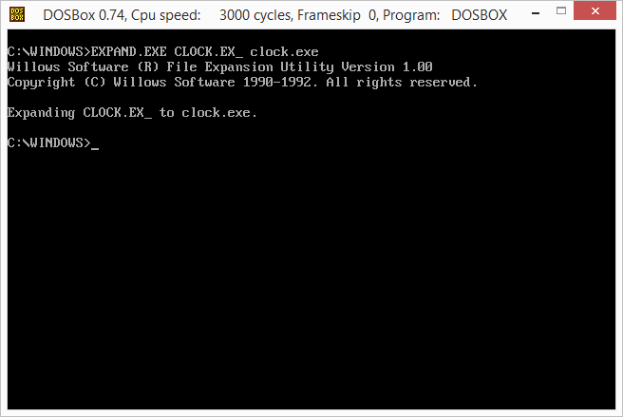Expand

Note
This tool will be moved to DOS tools later
Win16 Applications
Calculator Calendar CARDFILE CHARMAP Clipboard Viewer Clock Control Panel DRWATSON EXPAND FASTOPEN MPLAYER MSD Notepad PACKAGER PBRUSH PIF Editor printman Program Manager regedit setup SOL soundrec System Configuration Editor Task Manager WINFILE WINHELP Minesweeper winsheld Windows Version write

